SQL
Structured Query Language

- SQL use for accessing and manipulating databases.
- RDBMS – MS SQL Server, My SQL, Oracle, IBM DB2
- SQL keywords are not case sensitive

KEYWORD
SELECT | Select data from db | Select *  From <table name>
WHERE | filter out the results according to our requirements and different conditions. use the relational operators and keywords to define the conditions in the WHERE clause. =,!= or<>, >,=,<=, and, between, not between, in, not in, is null ,is not null, like, not like | Select <column name>  From <table name>  Where<condition>
ORDER BY | sort the results of a query. It sorts the result in ascending order by default. To sort the records in descending order, use the DESC keyword. | Select <column name>  From <table name>  Order by <column name>ASC|DESC;
GROUP BY | to arrange identical data into groups with the help of some functions. if a particular column has same values in different rows then it will arrange these rows in a group.  - GROUP BY clause is used with the SELECT statement.  - placed after the WHERE clause.  - placed before ORDER BY clause if used any.  - Use only if it needed according to the given question. | Select <column name>  From <table name>  Where <condition>  Group by <column name>  Order by<column name>
HAVING | used to filter groups of records based on a condition, typically following a GROUP BY clause.. The HAVING clause was added to SQL because the WHERE keyword could not be used with aggregate functions | Select <aggregate function><column name>  From <table name>  Group by <column name>  Having <condition>

LIKE | Search for a pattern
IN | To specify multiple possible values for a column
AND | displays a record if all the conditions separated by AND are TRUE
OR | displays a record if any of the conditions separated by OR is TRUE
NOT | NOT operator displays a record if the condition(s) is NOT TRUE

Aggregate Functions
An aggregate function performs a calculation on a set of values, and returns a single value. Aggregate functions ignore null values. Aggregate functions allows us to get summarized data from the database.

Select <function> <(column name)>
From <table name>

Function | Description
COUNT() | Function returns the number of rows that matches a specified criterion.
SUM() | Function returns the total sum of a numeric column.
MAX() | Function returns the largest value of the selected column.
MIN() | Function returns the smallest value of the selected column.
AVG() | Function returns the average value of a numeric column.
ROUND() | used to round the value up to a specific decimal places
FIRST() | Returns the first value in a column.
LAST() | Returns the last value in a column.

Difference between WHERE clause and HAVING clause.
The main difference between WHERE and HAVING clause comes when used together with GROUP BY clause
• WHERE is used to filter rows before grouping
• HAVING is used to exclude records after grouping.

Create table
Create table <table name>(
<column name> data type,
<column name> data type,
<column name> data type,
);

Data type | Definition
Integer | For numbers.
Char() | Use to store textual information.  The char data type is used to hold a fixed length text.
Varchar() | Used to store textual information.  The varchar data type is similar to char but stores variable length text.  Eg:char(10) – to store the NIC values.  Varchar(50) – To store the address of a customer.
Datetime | For date and time.
Real | For floating point numbers
Money | For currency values.

Primary Key  Constraint | 1.  2. | Primary key (column name) constraint <constraint_name> primary Key (<column _name>) | The PRIMARY KEY constraint uniquely identifies each record in a table. Primary keys must contain UNIQUE values, and cannot contain NULL values.
Foreign Key  Constraint | 1.  2. | Foreign key (referncing column) refernces <refernced table>  (refernced column) constraint <constraint_name> foreign key  (<this_table_column_name>) references <reference_table>  (<reference_table_column_name>) | A FOREIGN KEY is a key used to link two tables together.  A FOREIGN KEY is a field (or collection of fields) in one table that refers to the PRIMARY KEY in another table.
Check Constraint | - Check <condition>  - constraint <constraint_name> check (<put the condition here>) |  | The CHECK constraint is used to limit the value range that can be placed in a column.

Insert, Update and Delete commands

INSERT INTO | To insert new records in a table. | There are 2 ways.  - Both the column names and the values to be inserted  insert into<table name>(column name,column name,….)  values(value 1,value 2,…)  - Adding values for all the columns of the table, do not need to specify the column names in the SQL query.  insert into <table name>  Values(value1,value2,..)
UPDATE | modify the existing records in a table | Update<table name>  Set <column name>=<value>  Where<condition>  If omit the WHERE clause, all records in the table will be updated.
DELETE | delete existing records in a table | Delete<table name>  Where<condition>

Table joining
When retrieving data from two or more related tables in a relational database, matching rows of tables are joined together to produce the answer. Here the rows of tables are combined, based on a related columns between them.
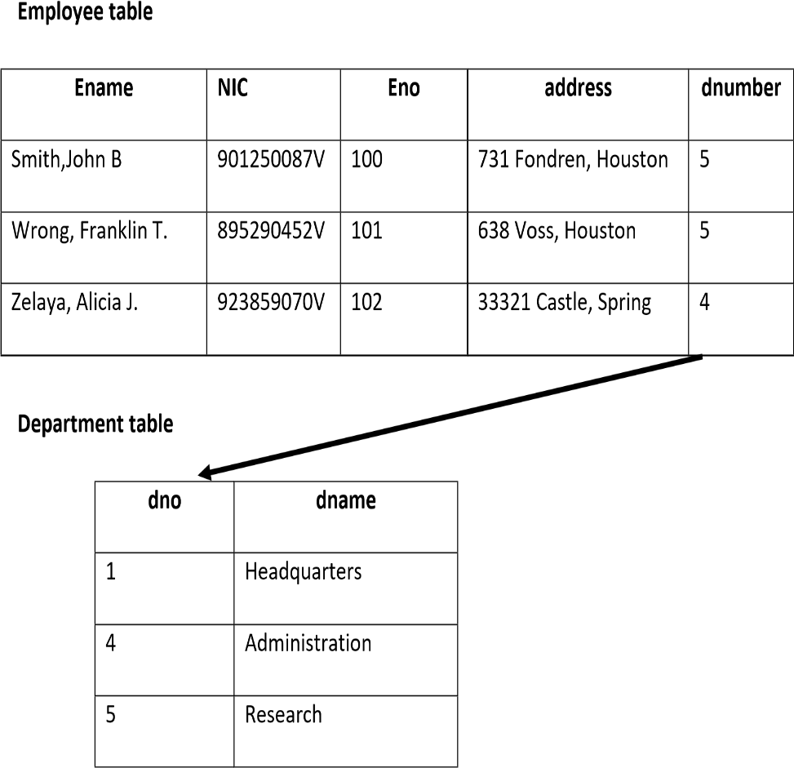

Select e.Ename , d.dname
From Employee e,Department d
Where e.dnumber = d.dno

both tables have the similar data in their Department number columns (dno , dnumber) . Employee table ‘dnumber’ column refer the data in Department table ‘dno’ column. can join both of these tables using that ‘dno’ and ‘dnumber’ columns.

A JOIN clause is used to combine rows from two or more tables, based on a related column between them.
- (INNER) JOIN: Returns records that have matching values in both tables
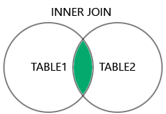

- LEFT (OUTER) JOIN: Returns all records from the left table, and the matched records from the right table

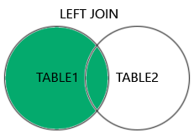
- RIGHT (OUTER) JOIN: Returns all records from the right table, and the matched records from the left table

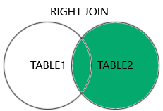
- FULL (OUTER) JOIN: Returns all records when there is a match in either left or right table

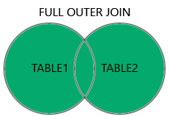

Example
create table works(
Eid int,
Did varchar(20)
Pct_time int,
Constraint work_pk primary key (eid,did),
Constraint work_fk1 foreign key (eid) references Emp,
Constraint work_fk2 foreign key (did) references Dept,)

Base table
A base table in SQL is a table that physically exists in the database and stores data directly. It is not the result of a query or a view, but rather a permanent table where data is inserted, updated, or deleted. Base tables form the foundational structure for the database schema and hold the actual records used by the application.
Key Characteristics of a Base Table:
- Persistent Storage: Data is stored permanently in the base table until explicitly modified or removed by INSERT, UPDATE, or DELETE operations.
- Direct Interaction: SQL queries can directly access base tables for reading and writing data.
- Used in Views: Base tables are often used as the source of data in views or queries, which might manipulate or present the data in a different form.
- Schema Defined: The structure of a base table is defined by its columns and data types when it is created using the CREATE TABLE statement.

VIEWS

- A view is a virtual table which is derived from other tables which are called base tables or defining tables.(Creating a temporary table for temporary requirements)
- A view does not necessarily exist in a physical form.

Create view <view name> <new column name> as
Select <column name>
From <table name>
Where <condition>

- Can rename column name.
- If modify created view table write a query
Drop view <view table name>

UPDATE VIEW

- Views containing aggregate functions are not updateable

Advantages :

- Security – restricting unauthorized access.
- Query simplicity – A view can draw data from several different tables and present it as a single table, turning multi-table queries into single-table queries against the view.
- Data Abstraction: Views allow you to hide the complexity of SQL queries. Users can interact with a simpler query structure without worrying about the underlying joins or complex queries in the base tables.
- Security: Views can limit access to specific rows and columns of a table, restricting sensitive data from being exposed. You can grant users access to a view without giving them full access to the base table.
- Reusability: A view encapsulates a query, so the same logic doesn’t need to be rewritten. You can reference the view as many times as needed across different parts of an application.
- Simplicity in Querying: Views simplify complex queries by allowing you to query a pre-defined set of data, making your overall code cleaner and easier to maintain.
- Data Consistency: Since views are based on base tables, any updates to the base tables are automatically reflected in the view. This helps maintain consistency without needing to manually update the view.
- Logical Data Independence: Views help maintain logical separation between how data is stored and how it is presented, which is useful for changing database structures without affecting how data is accessed.

Disadvantages :
- Performance
- Update restrictions
- Overhead: Since views are virtual tables, querying them can lead to slower performance, especially if the view is complex or based on multiple large tables. Each time the view is queried, the underlying query is executed, which may result in inefficient processing.
- Read-Only Views: Some views, especially those involving multiple tables or complex queries (e.g., aggregations), may not be updatable. This means you cannot directly insert, update, or delete data through such views.
- Limited Functionality: Views cannot include certain SQL features such as ORDER BY (unless used with TOP or LIMIT), and some types of views cannot be indexed, which can limit performance optimization.
- Dependency Management: When you drop or modify the structure of a base table, it can break views that depend on that table, leading to potential errors. Managing dependencies between views and base tables can be challenging in complex databases.
- Maintenance Overhead: If views are overused or layered on top of each other, they can become difficult to maintain, especially as the base tables or requirements change.

Example

- Create a view named dept_info that contains name of the department, budget and manager’s name

create view dept_Info(depId,Budgets,Name) as
select d.did,d.budget,e.ename
from dept d,emp e
where d.managerId=e.eid

select *
from dept_Info
drop view dept_Info

- Create a view named emp_info which contains eid, name, salary and total percentage of time.

create view emp_Info(EID,ENAME,ESALARY,ETIME)as
select e.eid,e.ename,e.salary,sum(w.pct_time)
from emp e , works w
where e.eid=w.eid and e.salary>89000
group by e.eid,e.ename,e.salary

select*
from emp_Info
drop view emp_Info

- update the view - not possible ,updating view can be ambiguous

update emp_Info
set ETIME=95
where EID

select *
from dept

- possible update
update dept
set budget=100000
where did='ITSD'

T-SQL

- T-SQL stands forTransact SQL and is sometime referd to as SQL,is an extension of the SQL language use primary with MS SQL Server.This means that is provides all the functionality of but with some added extras.

Variable

Declare @<variable name>
<data type> data
Set @<variable name> = <value>
Print @<variable name>

Example
create a variable
declare @ID
varchar(20)
assign a value to variable
set @ID='IT22548078'
Display the variable value
print @ID
using variables in the sql script example 1
(not hardcode without getting value. only get variable name)
declare @ID
varchar(20)
set @ID='ITSD'
select budget
from dept
where did=@ID

using variables in the sql script example 2
declare @ID
varchar(20)
declare @ecount
int
set @ID='ITSD'
select @ecount =COUNT(eid)
from works
where did=@ID
print @ecount

IF statement
- Begin and end part only use if have multiple lines, more than one line.

If (select count(eid from emp)>5
Begin
Print ‘ Inside if’
Print’AAA’
End
Else
Print ‘outside if’

while statement

- Sets a condition for the repeated execution of an SQL statement or statement block.
- The statements are executed repeatedly as long as the specified condition is true.
- The execution of statements in the WHILE loop can be controlled from inside the loop with the BREAK and CONTINUE keywords.

Example
create table employee(
id int primary key,
name varchar(30)
)

select *
from employee

declare @count
int
set @count=1
while @count<=100
begin
insert into employee
values(@count,CONCAT('employee',@count))
set @count=@count+1
end

Functions/Procedures

- Use to maintain business logic. Business logic is maintained in database tier for data intensive operations.
E.g. Calculating all interest earned in bank accounts

- No need to write code again and again. we have a block and can call it.
- Input not have any keyword. Input parameter design base on @ sign and variable name and data type only. It is in default mode.

Differences between functions and procedures

Functions | Procedures
Accept multiple inputs | Accept multiple inputs
Return only one value. Not output.it call return value | Return multiple outputs
Parameter mode IN | Parameter mode IN or OUT
IN parameter are default.do not mention it. | OUT parameter must mention.
Compulsory to have return value. | Sometime not compulsory to have return value.As an example not display data. But Insert data as an input but there are no any output.
Create function <function name>(parameters)  Returns <return type>  <function body> | Create procedure <procedure name> (parameters)  <procedure body>  <procedure body>

Functions
Example
Create a function that returns the number of employees in a given department.
--create a function that returns the number of emplyees in a given department
create function getEmpCount (@deptName varchar (30))
returns int
as
begin
declare @ecount int
select @ecount=count(eid)
from works
where did=@deptName
return @ecount
end
--calling the function
declare @result int
exec @result=getEmpCount 'ITSD' //call into function and change input type
print @result
Example
Create a function to return the total percentage of time a person works given the employee id.
create function getTotalTime(@empId int) returns int
as
begin
declare @total int
select @total =sum(pct_time)
from works
where eid=@empId
return @total
end
declare @r int
exec @r=getTotalTime 1000
print @r
Stored Procedure
A stored procedure is a prepared SQL code that you can save, so the code can be reused over and over again.
So if have an SQL query that yu write over and over again, save it as a stored procedure, and then just call it to execute it. can also pass parameters to a stored procedure, so that the stored procedure can act based on the parameter values that is passed

Example 1
Create a procedure to give a salary increment to all the employee by a given percentage from their existing salary.
--create a procedure
create procedure increaseSalary(@pct_time float)
as
begin
update emp
set salary=salary + salary * (@pct_time /100)
end
--calling the procedure
exec increaseSalary 20

Example 2
create a procedure that outputs statistics of salary (min, max) for a given department.

--create a procedure
create procedure displayStat(@did char(12),@minSal float output,@maxsal float output)
as
begin
select @minSal=min(e.salary),@maxSal=max(e.salary)
from works w, emp e
where e.eid=w.eid and w.did=@did
end

--calling the procedure
declare @min float,@max float //declare output parameters
exec displayStat 'ITSD',@min output,@max output
print @min
print @max

Example 3
Create a procedure that outputs the name of the manager and his salary in a given department.
create procedure managerDetails(@did char (12),@MName varchar(25) output,@MSalary float output)
as
begin
select @MName=e.ename,@MSalary=e.salary
from dept d,emp e
where d.managerId=e.eid and d.did=@did
end
--calling to procedure
declare @n varchar(25),@s float
exec managerDetails 'ITSD',@n output,@s output
print @n
print @s

Triggers

- Triggers are useful in enforcing business rules and data integrity.
- They are more powerful than general constraints(function).
Example - The employees salary is always less than his/her manager’s salary
- A trigger is a special type of stored procedure that automatically takes effect when the data in a specified table is modified. (do not need to call. Automatically execute when the table is modified)

Create tr1
On works // tr1 execute when modifications happen to works table
For insert

- There are two types of triggers.
- DDL Triggers (create, alter,drop) –when create the table and when modify the table the trigger happen.DDL triggers executed when a database object is created,altered or droped from the database.
- DML Triggers (insert, update, delete) – when write a trigger ,it will automatically execute in the table specify is modified. It can be insert, update or delete. execute when a user tries to modify data through a data manipulation language (DML) event.

DML Triggers

Create trigger <trigger name>
On <table name| View name>
For after| instead of
Insert| update| delete
As
Begin
<logic>
End

AFTER
after -> table-> logic
  - AFTER specifies that the DML trigger is fired only when all operations specified in the triggering SQL statement have executed successfully.
  - AFTER is the default when FOR is the only keyword specified. don’t need to mention “after” keyword.
  - AFTER triggers cannot be defined on views. Only for table
Example – create t1
On works
For insert //triggering sql statemnet

INSTEAD OF
instead ->logic
  - Specifies that the trigger is executed instead of the triggering SQL statement, thus overriding the actions of the triggering statements.
  - Specifies At most, one INSTEAD OF trigger per INSERT, UPDATE, or DELETE statement can be defined on a table or view.
Example - create t2
On dept
For instead of
Insert
Insert into dept
Values(),

inserted/deleted tables
- When a trigger is executed SQL Server creates two virtual tables called INSERTED and DELETED.
- The deleted table stores copies of the affected rows during DELETE and UPDATE statements
- The inserted table stores copies of the affected rows during INSERT and UPDATE statements

Create trigger t1 // After inserting to work t1 will execute, Insert into works table
On works
For insert
Insert into works
Values (1000,IT,20)
When doing modification(insert,update,delete) to table temporary table will be created. that temporary called inserted table. that inserted table give copy.
Create trigger t2
On works
For delete
Create a delete table and include copy of that deleted record.

Example 1:
  - Consider tables below
    - Account (accountNo, custId, branch, balance)
    - AccountAudit (accountNo, balance, date)
  - Create a trigger to track all inserts/updates done to the balance field of an Account table at a bank in the AccountAudit table
Create Account table and insert values.
create table Account(
accountNo int primary key,
cusId int,
branch varchar(30),
balance float,
)
insert into Account
values (1000,500,'Malabe',20000)

create Account Audit table and insert values
create table AccountAudit(
id int identity(1,1),
accountNo int,
balance float,
adate date,
)
Create trigger
create trigger audit
on Account
for insert,update
as
begin
declare @n int @bl float
select @n= i.accountNo,@bl=i.balance
from inserted i
insert into AccountAudit(accountNo,balance,adate)
values (@n,@bl,getDate())
end

--test

insert into Account
values(2000,501,'Matara',30000)
select * from Account
select * from AccountAudit
Initially Account table had only one record and nothing was there in AccountAudit table.
After inserted to Account table, logic was executed. Record inserted into AccountAudit table.

Functions
ASCII() function | returns the ASCII value for the specific character. | SELECT ASCII(Cname)
CHAR_LENGTH() | return the length of a string (in characters). | SELECT CHAR_LENGTH(Cname)
CHARACTER_LENGTH() | Return the length of a string | SELECT CHARACTER_LENGTH(Cname)
CONCAT() | Add two or more expression together | SELECT CONCAT(“My”,”name”,”is”,”Kavindya”)
CONCAT_WS() | add two or more expression together with separator | SELECT CONCAT_WS(“-“,”name’,”is”,”kav”)
FIELD() function returns the index position of a value in a list of values. | Return the index position of a value in a list of value | SELECT FIELD()

